Exercise 1: Implementing the Singleton Pattern

**CODE :**

using System;

namespace Singleton

{

public class Logger

{

private static Logger _instance;

private Logger()

{

Console.WriteLine("Logger instance created.");

}

public static Logger GetInstance()

{

if (_instance == null)

{

_instance = new Logger();

}

return _instance;

}

public void Log(string message)

{

Console.WriteLine($"Log: {message}");

}

}

internal class Program

{

static void Main(string[] args)

{

Logger logger1 = Logger.GetInstance();

logger1.Log("Hello SOHAM! This is the first log message.");

Logger logger2 = Logger.GetInstance();

logger2.Log("Hello SOHAM! This is the second log message.");

Console.WriteLine("Are both logger instances same? " + (logger1 == logger2));

Console.ReadLine();

}

}

}

**OUTPUT**

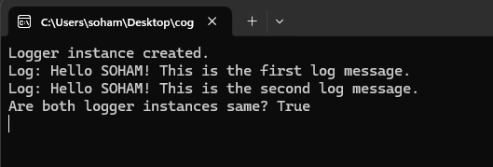

**Exercise 2:**

**Implementing the Factory Method Pattern**

CODE:

using System;

namespace Factory_Method_Pattern

{

public interface IDocument

{

void Open();

}

public class WordDocument : IDocument

{

public void Open()

{

Console.WriteLine("Opening Word Document.");

}

}

public class PdfDocument : IDocument

{

public void Open()

{

Console.WriteLine("Opening PDF Document.");

}

}

public class ExcelDocument : IDocument

{

public void Open()

{

Console.WriteLine("Opening Excel Document.");

}

}

public abstract class DocumentFactory

{

public abstract IDocument CreateDocument();

}

public class WordDocumentFactory : DocumentFactory

{

public override IDocument CreateDocument()

{

return new WordDocument();

}

}

public class PdfDocumentFactory : DocumentFactory

{

public override IDocument CreateDocument()

{

return new PdfDocument();

}

}

public class ExcelDocumentFactory : DocumentFactory

{

public override IDocument CreateDocument()

{

return new ExcelDocument();

}

}

internal class Program

{

static void Main(string[] args)

{

DocumentFactory factory;

factory = new WordDocumentFactory();

IDocument word = factory.CreateDocument();

word.Open();

factory = new PdfDocumentFactory();

IDocument pdf = factory.CreateDocument();

pdf.Open();

factory = new ExcelDocumentFactory();

IDocument excel = factory.CreateDocument();

excel.Open();

Console.ReadLine();

}

}

}

OUTPUT

